DATA ANALYTICS WITH POWER BI
PROJECT REPORT
(Project Semester September - December 2025)
US Aviation Performance and Delay Analysis Dashboard
Submitted by
Akash Kumar Malik
Registration No: 12323008
Section K23CN
Course Code: INT 374
Under the Guidance of
Mr. Jaffar Amin Chacket Sir
School of Computer Science and Engineering
Lovely Professional University, Phagwara

CERTIFICATE
This is to certify that Akash Kumar Malik bearing Registration no. 28 has successfully completed the INT 374 project titled, 'US Aviation Performance and Delay Analysis Dashboard' under my direct guidance and supervision. To the best of my knowledge, the present work is the result of his original development, effort, and study. No part of this project has been copied from any other source without proper citation.

Signature and Name of the Supervisor
Mr. Jaffar Amin Chacket
School of Computer Science and Engineering
Lovely Professional University
Phagwara, Punjab.

DECLARATION
I, Akash Kumar Malik, student of Data Analytics with Power BI under the CSE/IT Discipline at Lovely Professional University, Punjab, hereby declare that all the information furnished in this project report is based on my own intensive work and is genuine. I further declare that this work has not been submitted alongside any other degree or diploma to any other University or Institute.

Date: 20th December 2025 | Signature: Akash Kumar Malik  Reg No: 12323008

ACKNOWLEDGEMENT
I would like to express my special thanks of gratitude to my respected teacher and guide, Mr. Jaffar Amin Chacket Sir as well as our principal, who gave me the golden opportunity to do this wonderful project on the topic 'US Aviation Performance and Delay Analysis Dashboard'. This project has helped me in doing a lot of research, and I came to know about so many new things regarding data analytics, ETL processes, and dashboard design.
Secondly, I would also like to thank my friends who helped me a lot in finalizing this project within the limited time frame. Their encouragement and support were invaluable in overcoming the technical challenges encountered during the development phase.

TABLE OF CONTENTS
S.No | Topic
1 | Introduction
2 | Source of Dataset
3 | Dataset Preprocessing
4 | Analysis on Dataset (General Description & Specific Requirements)
5 | Analysis Results & Visualization
6 | Conclusion
7 | Future Scope
8 | References

1. INTRODUCTION
The US Aviation Performance and Delay Analysis Dashboard is a state-of-the-art analytical Dashboard designed to provide deep insights into the operational efficiency of the United States aviation sector. In an industry where minutes of delay translate to millions of dollars in losses and significant customer dissatisfaction, having a robust mechanism to track, analyze, and visualize performance metrics is crucial.
This project leverages the power of Microsoft Power BI for visualization and Python for Data Engineering (ETL) to process and present data from over 530,000 flight records. The core objective is to answer critical business questions regarding flight delays, cancellations, and airline reliability. The dashboard is structured into multiple layers of analysis, ranging from a high-level specific Executive Overview (CEO View) to granular Network Analysis (Operations View) and Competitive Benchmarking (Strategy View).
A key distinguishing feature of this dashboard is its 'Glassmorphism' design aesthetic. Moving away from traditional, flat dashboard designs, this project employs a modern interface with translucent containers, a light grey background (#F0F2F5), and a consistent dark blue header (#1A5276). This not only enhances visual appeal but also improves user engagement and readability.

Dashboard Landing Page
The landing page serves as the entry point, offering intuitive navigation to the different analytics modules. It features a realistic airport aesthetic to set the context immediately.
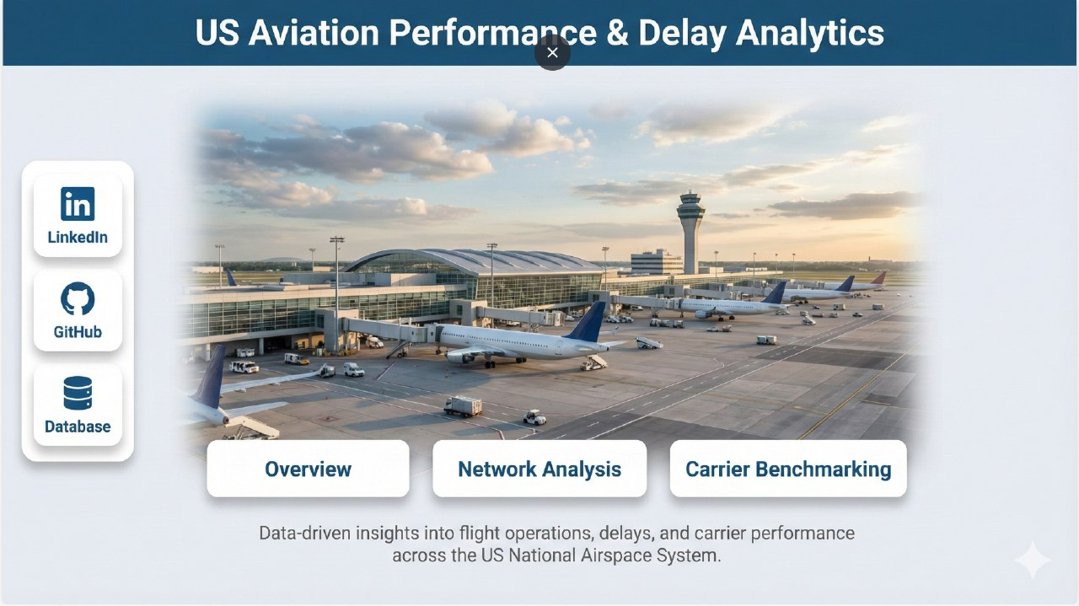

2. SOURCE OF DATASET
The foundation of any analytics project is the quality of its data. For this dashboard, the data was sourced from the US Department of Transportation (Bureau of Transportation Statistics - BTS). The specific dataset used is the 'Reporting Carrier On-Time Performance', which tracks on-time arrival data for non-stop domestic flights by major air carriers.
The time period selected for this analysis is from January 2024 to December 2024. While the full annual dataset contains approximately 6 million rows, a strategic decision was made to downsample the data to approximately ~ 500,000+ rows. This volume strikes an optimal balance, providing statistical significance for trend analysis while ensuring that the Power BI dashboard remains responsive and performant on standard hardware.

3. DATASET PREPROCESSING
Raw data is rarely ready for immediate analysis. Extensive Data Engineering and ETL (Extract, Transform, Load) processes were performed using Python (Pandas library) to prepare the data. The preprocessing pipeline consisted of three distinct and critical scripts:

3.1 Data Downsampling (downsample_csv.py)
Handling millions of rows can slow down development and end-user experience. The `downsample_csv.py` script was created to reduce the dataset size intelligently. It employs a random sampling technique using `df.sample(frac=0.10, random_state=42)`. The usage of `random_state=42` is critical as it ensures reproducibility; every time the script is run, it produces the exact same subset of data, allowing for consistent testing and validation.

3.2 Data Integration (combine_csvs.py)
The raw data from BTS is often provided in monthly chunks. To analyze trends over time, these separate files needed to be merged. The `combine_csvs.py` script handles this by merging multiple CSV files into a single master file. A standout feature of this script is its 'Robust Scan' logic. It first scans all files to identify the intersection of common columns. This prevents the merging process from crashing if one month's file has an extra or missing column compared to another, ensuring a seamless integration process.

3.3 Feature Optimization (filter_columns.py)
The raw dataset contains over 100 columns, many of which are irrelevant for this specific analysis (e.g., specific taxi-out times or wheel-off times). The `filter_columns.py` script systematically drops these unused columns to optimize Power BI performance. The final schema retains only the 21 most impactful columns:
- Identity Columns: Marketing_Airline_Network (Carrier Code), Flight_Number, Tail_Number.
- Spatial/Temporal Columns: FlightDate, Origin, OriginCityName, Dest, DestCityName.
- Metrics: DepDelay, ArrDelay, Cancelled, Diverted, Distance.
- Root Cause Analysis: CarrierDelay, WeatherDelay, NASDelay, SecurityDelay, LateAircraftDelay.

4. ANALYSIS ON DATASET
The analysis is segmented into three distinct pages, each catering to a different stakeholder group within the airline management hierarchy.

4.1 Overview: The Executive Control Tower
This page is designed for the C-Suite and VPs. The objective is to provide a high-level health check of operations. Key Performance Indicators (KPIs) such as Total Flights, On-Time Performance (OTP) %, and Cancellation Rate are prominently displayed at the top.
Visual Insights:
1. Trend Line Chart (OTP % vs Cancellation %): This visual allows executives to see the correlation between cancellations and on-time performance over time. It includes a forecasting feature to predict future performance based on historical trends.
2. Donut Chart (Flight Status): A quick-glance distribution showing the proportion of flights that were On-Time, Delayed, or Cancelled.
3. Clustered Bar Chart (Top 5 Airlines): This compares flight volume against OTP. Conditional formatting is applied here—green bars indicate >80% OTP and red indicates <70%, making underperforming airlines instantly visible.
4. Multi-Row Card: Shows Month-over-Month (MoM) percentage changes, giving context to whether performance is improving or deteriorating.
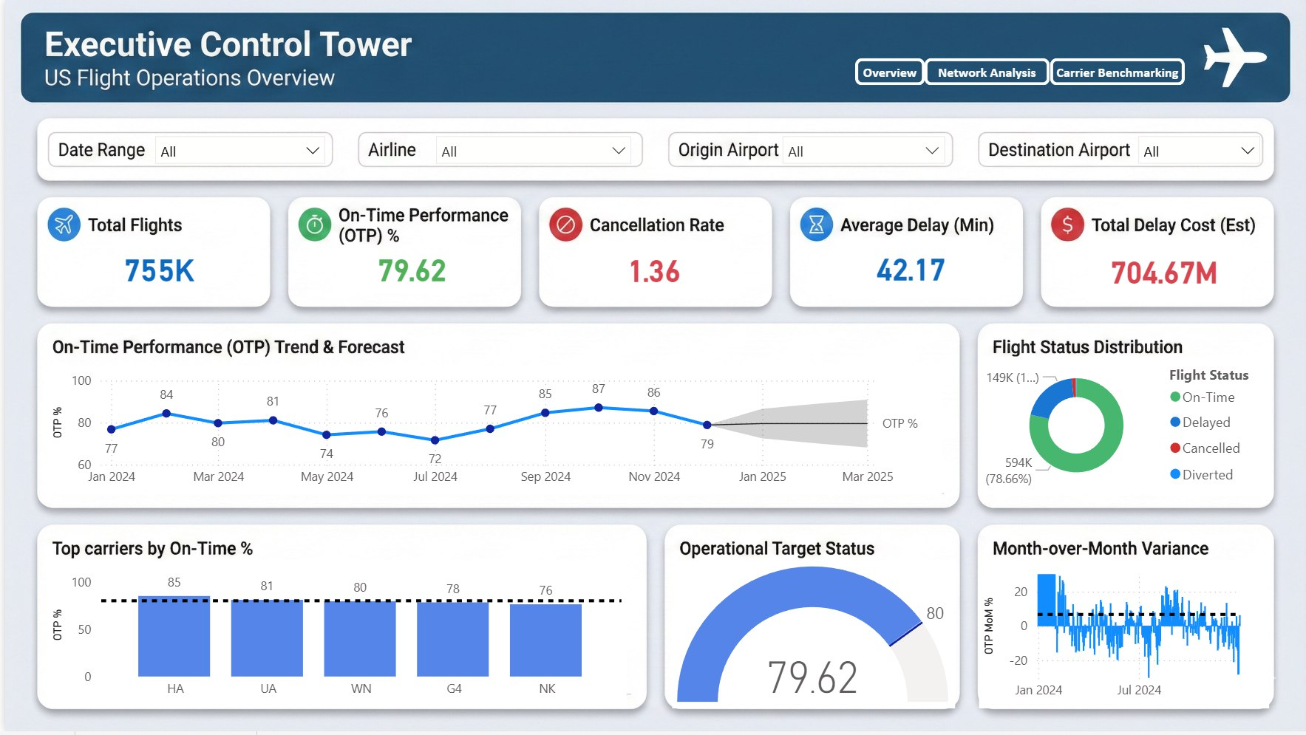

4.2 Network Analysis: Geo-Spatial Intelligence
Targeted at Operations Managers, this page moves from high-level metrics to distinct route-based analysis. It answers questions about where bottlenecks are occurring physically in the network.
Visual Insights:
1. Flow Map: This geospatial visualization connects Origin airports to Destination airports. The width of the lines represents flight volume, allowing managers to instantly identify high-traffic corridors.
2. Matrix Heatmap: This grid (Rows=Origin, Cols=Destination) uses a color gradient to highlight Average Delays. Red cells indicate routes with chronic delays, enabling targeted operational interventions.
3. Scatter Plot (Distance vs Arrival Delay): This analytical chart tests the hypothesis of whether longer flights incur more delays. The inclusion of an average line helps identify outliers—short flights with disproportionately high delays.
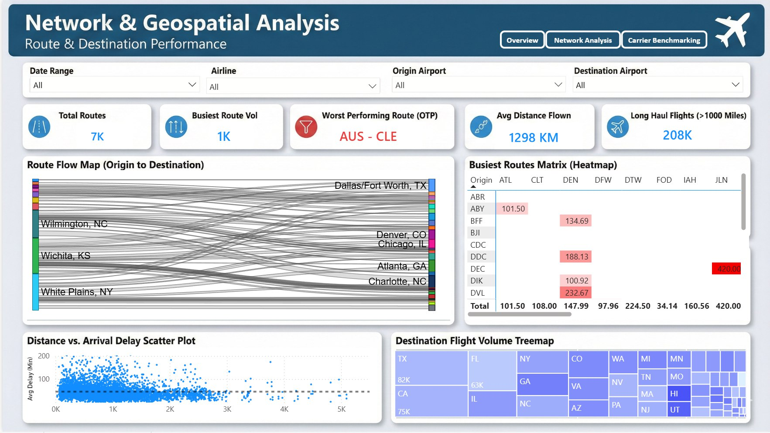

4.3 Carrier Benchmarking: The Competitor View
This page serves the Strategy Team. It uses 'Marketing_Airline_Network' codes to compare major brands like Delta and United, filtering out noise from regional subcontractors. The goal is to understand market position relative to competitors.
Visual Insights:
1. Ribbon Chart: A powerful visual that shows the ranking of airlines by OTP over time. As performance changes, the ribbons cross over each other, dynamically showing how market leaders shift month by month.
2. Radar Chart: A multi-variate comparison of three selected airlines across five distinct metrics: OTP, Speed, Reliability, Customer Satisfaction (proxied by low cancellations), and Efficiency. This provides a holistic view of airline strengths.
3. Dumbbell Chart: Compares Scheduled Elapsed Time vs Actual Elapsed Time. Large gaps here indicate efficient padding of schedules or consistent operational failures.
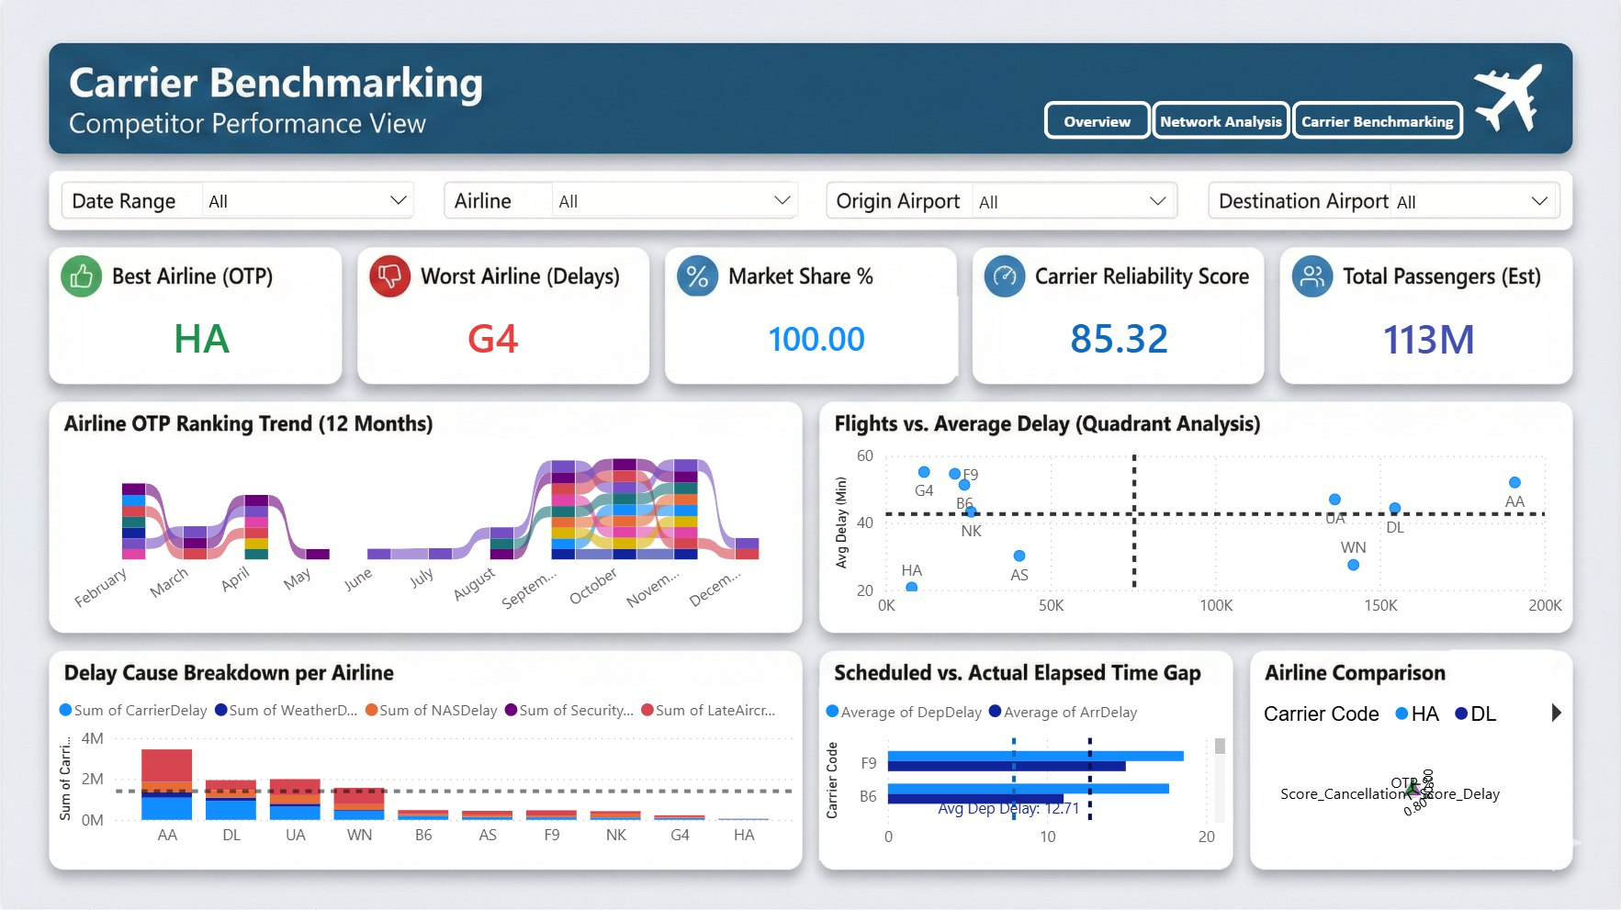

5. CONCLUSION
The US Aviation Performance and Delay Analysis Dashboard successfully bridges the gap between raw data and strategic decision-making. By rigorously preprocessing the data using Python, we ensured that the analysis was built on a clean, consistent foundation. The subsequent visualization in Power BI validates that data-driven insights can significantly enhance operational visibility.
The analysis revealed that while weather remains a significant uncontrollable factor, a substantial portion of delays stems from carrier-specific operations and late aircraft arrivals—factors that are within management's control. The dashboard empowers stakeholders to pinpoint these inefficiencies, from the broad executive level down to specific route-based bottlenecks.

6. FUTURE SCOPE
While the current dashboard is comprehensive, there are several avenues for future enhancement:
1. Real-Time Data Integration: Currently, the dashboard relies on static monthly CSVs. Integrating an API for real-time flight status would transform this into a live monitoring tool.
2. Predictive Analytics: Implementing Machine Learning models (e.g., Random Forest or XGBoost) to predict the probability of a delay before a flight takes off could allow for proactive passenger notifications.
3. Financial Impact Analysis: integrating ticket price data would allow the dashboard to calculate the exact revenue loss due to cancellations and delays, adding a financial dimension to the operational analysis.

7. REFERENCES
[1] Bureau of Transportation Statistics. (n.d.). Reporting Carrier On-Time Performance. US Department of Transportation. Retrieved from transtats.bts.gov
[2] Microsoft. (n.d.). Power BI Documentation. Microsoft Learn. Retrieved from learn.microsoft.com
[3] Pandas Development Team. (2023). pandas: powerful Python data analysis toolkit. Retrieved from pandas.pydata.org
[4] Few, S. (2006). Information Dashboard Design: The Effective Visual Communication of Data. O'Reilly Media.

